Asymmetric 12” 5+1 groove canister connected to charge port on reactor
Enclosure
Reactor
Chargepoint SBV within enclosure connected to 25L rigid container
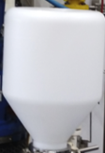
12” sleeve incorporated into body of enclosure connected to 12” 5+1 groove canister and secured by O-ring and band clamp

